
A Project Report
On
<<Domestic violence silent alert system >>
For

U23IT406- JAVA Programming Laboratory-Project
Submitted by

AFREENA S | (61782324106002)
AHAMED SHALIGH A | (61782324106003)
DEVISHREE G K | (61782324106016)

BACHELOR OF TECHNOLOGY
In
INFORMATION TECHNOLOGY

SONA COLLEGE OF TECHNOLOGY (AUTONOMOUS)
SALEM– 636005

APRIL 2026

SONA COLLEGE OF TECHNOLOGY, SALEM

(AUTONOMOUS)

BONAFIDE CERTIFICATE

This is to certify that the project titled “Domestic violence silent alert system” submitted by Afreena S (617823241002), Ahamed Shaligh A (617823241003), DeviShree G K (61782324106016) for the U23IT406- JAVA Programming Laboratory Course, is a bonafide record of work carried out under my supervision.

Head of the Department Signature of Faculty Incharge

Dr.J.Akilandeswari Mr.J.L.Aldo Stalin
Professor Assistant Professor
Department of Information Department of Information
Technology Technology
Sona College of Technology, Sona College of Technology,
Salem – 636005 Salem – 636005

INTERNAL EXAMINER
ACKNOWLEDGEMENT

First and foremost, we thank the power of almighty for showing us inner peace and for all blessings. Special gratitude to our parents, for showing their support and love always.
We express our sincere thanks to Chairman Sri.C.Valliappa and Vice Chairmen Sri. Thyagu Valiappa and Sri. Chocko Valliappa for providing adequate facilities to complete the project.
We extend our sincerest gratitude to our esteemed Principal Dr. S. R. R. Senthil Kumar, for his unwavering dedication, guidance, and vision. We are truly privileged to have such a visionary leader steering our academic endeavors.
We are immensely grateful to Head of Information Technology, Dr. J. Akilandeswari for the continued encouragement to complete the project.
We extend our deepest gratitude to our project Incharge Mr.J.L.Aldo Stalin
for his unwavering support and valuable guidance throughout project work. His expertise and patience were invaluable to us, and we are truly grateful for her/his remarkable contributions and valuable guidance and fruitful discussions throughout the course of the project work.
We feel proud to share this success with all our faculty members, family members and friends who helped directly or indirectly in completing this project successfully.

ABSTRACT
The Domestic Violence Silent Alert System is a desktop-based application developed using Java to provide immediate assistance during emergency situations. The system allows users to send instant alerts to predefined trusted contacts through SMS, WhatsApp and voice calls. It integrates Twilio API for communication and uses GPS-based location tracking to share real-time location details. The main objective of this system is to enable victims to send alerts silently without attracting attention. Key features include contact management, alert triggering using shortcut keys, alert history tracking, and customizable messages. The application ensures fast communication, reliability, and ease of use. This project demonstrates the effective use of Java, database connectivity, and API integration for real-world safety applications.

TABLE OF CONTENTS
- Introduction
- Problem Statement
- System Requirements
- Technologies Used
- System Design & Architecture
- Database Design
- Frontend Development
- Backend Development
- API Design & Integration (If Applicable)
- Results & Screenshots
- Conclusion
- Future Enhancements
- References
- Appendix / Annexure (Source code)

1. INTRODUCTION
Domestic violence and emergency situations require immediate response. In many cases, victims are unable to communicate openly due to fear or danger. This project provides a solution by enabling silent alert communication. The system is designed to send emergency alerts quickly to trusted contacts. It reduces response time and improves safety.

Objectives:
- To develop a silent alert system
- To send alerts with location details
- To store user and alert data
- To provide a simple user interface

Modules:
- Contact Management
- Alert Trigger System
- Alert History
- Settings Configuration
2. PROBLEM STATEMENT
Many existing emergency systems require visible interaction like phone calls or messages. In dangerous situations, this may not be possible.

Issues:
- No silent communication method
- Delay in sending alerts
- Lack of real-time location sharing

Solution:
The proposed system allows users to send alerts silently using a shortcut key. It automatically sends messages and location details to saved contacts.
3. SYSTEM REQUIREMENTS
3.1 Software Requirements
- Operating System: Windows / Linux
- Programming Language: Java
- IDE: NetBeans / IntelliJ IDEA
- Database: MySQL
- Connectivity: JDBC
- API: Twilio
3.2 Hardware Requirements
- Minimum 4GB RAM
- Dual Core Processor
- 40GB Hard Disk
- Internet Connection
4. TECHNOLOGIES USED

Java
Used for application development and GUI design.

Swing / JavaFX
Used to create user interface.

MySQL
Used to store contacts and alert history.

JDBC
Used for database connectivity.

Twilio API
Used for sending SMS and making calls.

GPS Integration
Used to share real-time location.
5. SYSTEM DESIGN & ARCHITECTURE
The Domestic Violence Silent Alert System is designed using a modular and layered architecture to ensure scalability, reliability, and easy maintenance. The system separates different functionalities into independent modules so that each component can operate efficiently without affecting others.
The architecture follows a three-tier design approach:
User Interface
This layer is responsible for user interaction. It is developed using Java Swing/JavaFX and provides a simple and user-friendly interface.
Functions:
- Accept user inputs (contacts, settings)
- Trigger emergency alerts
- Display alert history
- Provide navigation between modules
Key Screens:
- Home Screen
- Contacts Management
- Settings Panel
- Alert Status Screen
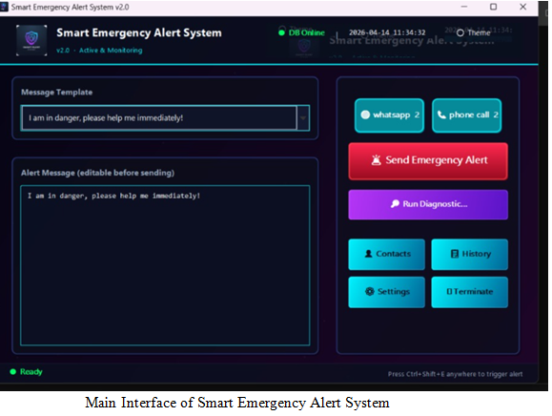
ARCHITECTURE FLOW
The overall system flow is as follows:
- User triggers alert (button/shortcut key)
- System fetches stored contacts from database
- Location is obtained using GPS/IP service
- Alert message is generated
- Twilio API is invoked
- SMS/Call/WhatsApp alerts are sent
- Alert status is stored in database
- User can view alert history
Flow Representation:
User → UI → Alert Module → Database → Twilio API → Contacts
↓
Alert Logs Stored
8. BACKEND DEVELOPMENT
The backend is implemented using Java.

Functions:
- Fetch contacts from database
- Send alerts using Twilio
- Store alert logs
- Handle errors
Example modules:
- AlertService
- DatabaseManager
9. API DESIGN & INTEGRATION
The system integrates Twilio API.

Features:
- Send SMS alerts
- Make voice calls
- WhatsApp messaging

JDBC:
Used to connect Java with MySQL database.
10. RESULTS & SCREENSHOTS
10.1 Module Description
10.1.1 Trusted Contact Management Module
This module allows users to add, update, and delete trusted contacts. These contacts will receive alert during emergencies
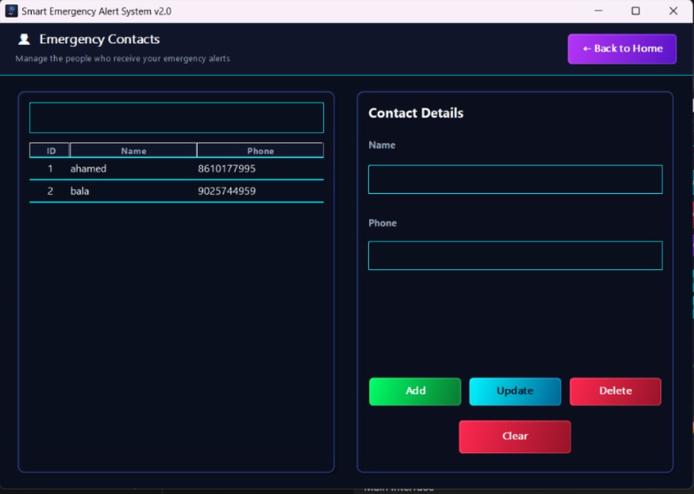
Emergency Contact Management System
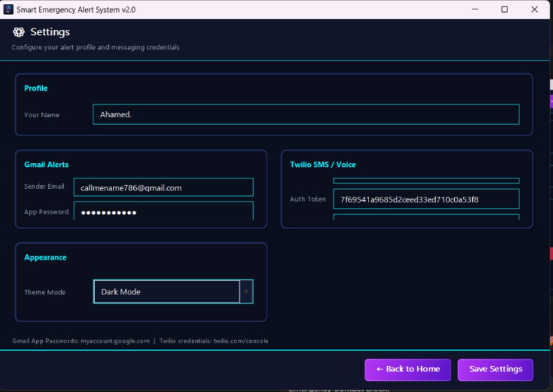
Settings Module – User Configuration and API Setup
10.1.2 Silent Alert Trigger Module
This module enables users to send a silent alert by clicking a button. The system sends alerts to all saved contacts instantly.
(Secret key : CTRL + SHIFT + E)
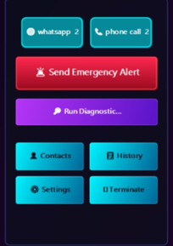
Send Emergency Alert Button Interface

10.1.3 Alert History Module
This module stores all alert records including date, time, and status. Users can view past alerts for reference.
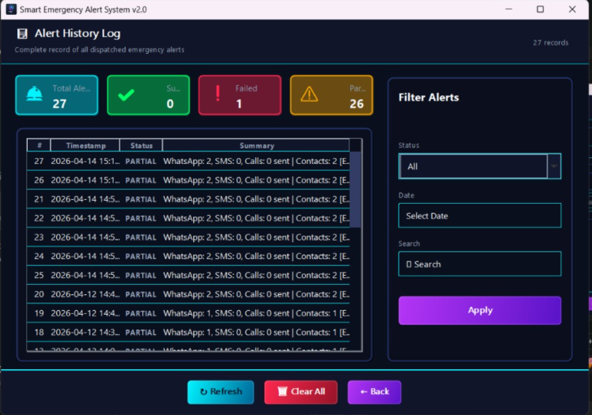
Alert History Management Module
10.2.4 Final Emergency Alert Output With Location
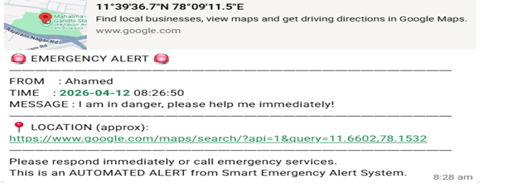
11. CONCLUSION
The Domestic Violence Silent Alert System is successfully developed. It provides a secure and efficient way to send emergency alerts.

Achievements:
- Real-time alert system
- API integration
- Database management

Skills gained:
- Java programming
- Database connectivity
- API usage
12. FUTURE ENHANCEMENTS
- Mobile application development
- GPS live tracking
- Wearable device integration
- Cloud database support
13. REFERENCES
- Java Documentation (Oracle)
- MySQL Documentation
- Twilio API Documentation
- Stack Overflow
- GeeksforGeeks
14. APPENDIX / ANNEXURE (SOURCE CODE)
14.1 Alert Service Module
This module is the core component responsible for sending emergency alerts using Twilio API.
Functionality:
- Fetches user location
- Prepares emergency message
- Sends SMS, WhatsApp, and Calls
- Works silently in background

package com.alertsystem.service;
import com.alertsystem.db.DatabaseManager;
import com.alertsystem.util.LocationUtil;
import com.alertsystem.ui.SettingsDialog;
import com.twilio.Twilio;
import com.twilio.rest.api.v2010.account.Call;
import com.twilio.rest.api.v2010.account.Message;
import com.twilio.type.PhoneNumber;
import com.twilio.type.Twiml;
import java.awt.Desktop;
import java.net.URI;
import java.net.URLEncoder;
import java.nio.charset.StandardCharsets;
import java.time.LocalDateTime;
import java.time.format.DateTimeFormatter;
import java.util.List;
public class AlertService {
public static String sendAlerts(String userName, String specificMessage) {
if (!checkInternetConnection())
return "ERROR: No internet connection.";
String locationLink = LocationUtil.getGoogleMapsLink();

String fullMessage = "EMERGENCY ALERT\nFROM: " + userName +
"\nMSG: " + specificMessage +
"\nLOCATION: " + locationLink;
List<String[]> contacts = DatabaseManager.getContacts();
if (contacts.isEmpty())
return "ERROR: No contacts found.";
Twilio.init(SettingsDialog.twilioSid.trim(), SettingsDialog.twilioToken.trim());
int calls = 0, sms = 0, wa = 0;
for (String[] contact : contacts) {
String phone = formatPhone(contact[2]);
if (sendWhatsApp(phone, fullMessage))
wa++;
sendCall(phone, userName);
sendSMS(phone, fullMessage);
}
return "Dispatched: WhatsApp: " + wa + " | Voice/SMS running...";
}
private static String sendCall(String toPhone, String userName) {
try {
String msg = userName + " is in danger. Please check WhatsApp for location.";
String twiml = "<?xml version=\"1.0\" encoding=\"UTF-8\"?>" +
"<Response><Say loop=\"2\">" + msg + "</Say></Response>";
Call.creator(
new PhoneNumber(toPhone),
new PhoneNumber(SettingsDialog.twilioPhone),
new Twiml(twiml)
).create();
return "OK";
} catch (Exception e) {
return e.getMessage();
}
}
}
14.2 Database Management Module
This module handles all database operations using MySQL and JDBC.
Functionality:
- Connect to database
- Fetch contacts
- Store alert logs

package com.alertsystem.db;
import java.sql.*;
import java.util.ArrayList;
import java.util.List;
public class DatabaseManager {
private static final String URL =
"jdbc:mysql://localhost:3306/emergency_db?createDatabaseIfNotExist=true";
private static final String USER = "root";
private static final String PASS = "root";
public static Connection getConnection() throws SQLException {
return DriverManager.getConnection(URL, USER, PASS);
}
public static List<String[]> getContacts() {

List<String[]> list = new ArrayList<>();
try (Connection conn = getConnection();
Statement stmt = conn.createStatement();
ResultSet rs = stmt.executeQuery("SELECT * FROM contacts")) {
while (rs.next()) {
list.add(new String[]{
String.valueOf(rs.getInt("id")),
rs.getString("name"),
rs.getString("phone")
});
}
} catch (SQLException e) {
e.printStackTrace();
}
return list;
}
public static void logAlert(String status, String message) {
try (Connection conn = getConnection();
PreparedStatement ps = conn.prepareStatement(
"INSERT INTO alert_logs (status, message) VALUES (?, ?)")) {
ps.setString(1, status);
ps.setString(2, message);
ps.executeUpdate();

} catch (SQLException e) {
e.printStackTrace();
}
}
}
14.3 UI Design Module
This module handles user interface styling.
Functionality:
- Creates emergency button
- Applies theme colors
- Designs background UI

package com.alertsystem.util;
import java.awt.*;
import javax.swing.*;
public class ThemeManager {
public static final Color PRIMARY_COLOR = new Color(0, 243, 255);
public static final Color BG_COLOR = new Color(10, 15, 30);
public static final Color SURFACE_COLOR = new Color(20, 30, 50);
public static JButton makeEmergencyButton(String text) {
JButton btn = new JButton(text);
btn.setBackground(new Color(220, 38, 38));
btn.setForeground(Color.WHITE);
btn.setFont(new Font("Segoe UI", Font.BOLD, 18));
btn.setFocusPainted(false);
btn.setBorder(BorderFactory.createLineBorder(PRIMARY_COLOR, 2));
return btn;
}
public static JPanel createFuturisticBackground() {

return new JPanel(new BorderLayout()) {
@Override
protected void paintComponent(Graphics g) {
Graphics2D g2 = (Graphics2D) g;
g2.setPaint(new GradientPaint(
0, 0, BG_COLOR,
0, getHeight(), SURFACE_COLOR
));
g2.fillRect(0, 0, getWidth(), getHeight());
}
};
}
}

14.4 GitHub Repository Link
The complete source code of the Domestic Violence Silent Alert System is available in the GitHub repository. It contains all modules including UI design, backend services, database integration, and API configuration.
GitHub Repository Link:
https://github.com/gkdevishree10022007-stack/Domesticviolence-silent-alert-system.git

